Chapter 7 Inheritance

- inheritance creates specialized class versions of a another class
- new class is called: derived/subclass/child class
original class is called: base/superclass/parent class
- derived class = (base class attributes + methods) + (new attributes + new methods)
inheritance list:
  - public methods (no private methods!)
  - all public and private instance variables
    - private instance variables should be accessed by public accessor and mutator
  - all public and private static variables
- 繼承的目的：重複再利用相同的資料，share!
- single inheritance: inherits from only one class
- <modifier> class <name> [extends <superclass>] {
<declarations>*
}
- 越上層的class的共同屬性越少，所能包含的類別越多。
越下層的class的共同屬性越多，所能包含的類別越少。
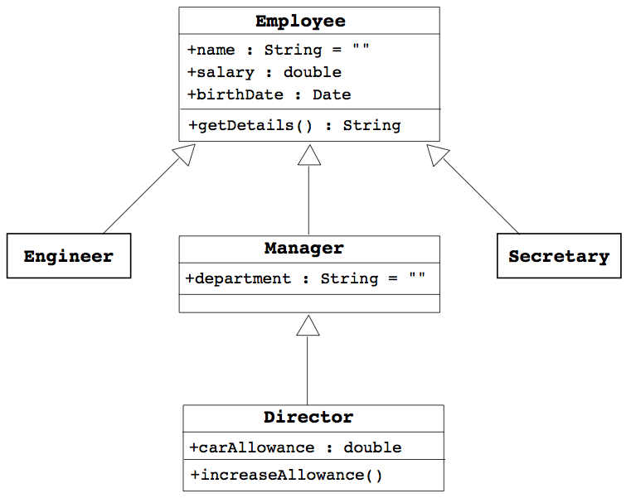
其他範例：數系（上層→下層）：實數→有理數→整數
圓錐曲線→橢圓、雙曲線、拋物線→圓 （越下層限制條件越多）

- overriding methods：subclass non-static method和superclass non-static method的method name、參數類型、回傳類型完全一樣 (因為static不care有沒有物件)
  - overloading methods：同一class下，有多個相同method name，但method的傳入參數類型或數量不同
  - access control 權限控制
Modifier | Same Class | Same Package | Subclass | Universe
private | Yes
default | Yes | Yes
protected | Yes | Yes | Yes
public | Yes | Yes | Yes | Yes

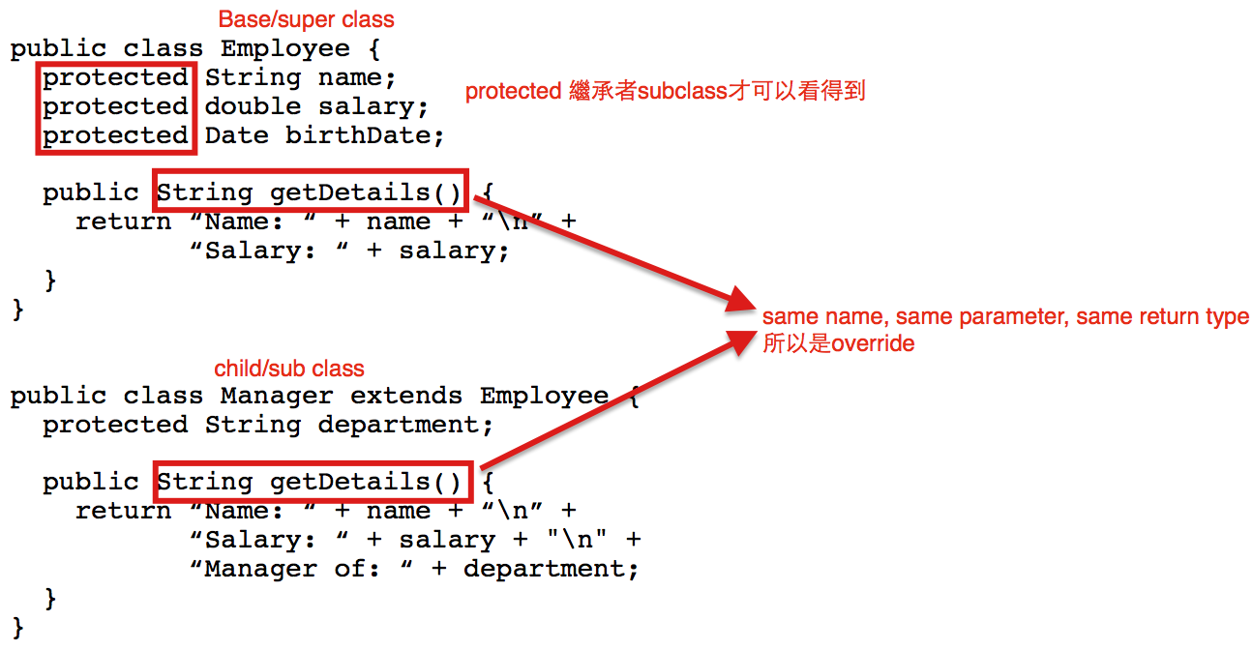
  - changing access permission of an overridden method
(only becoming more permissive，只能越來越公開)
    - base class: private void doSomething()
derived class: public void doSomething()
This is OK
    - base class: public void doSomething()
derived class: private void doSomething()
This is not OK
  - covariant return type：
    - 若return type是一種class，那這個return type可以為這個class或是這個class的繼承class。
    - if there is a return class type, then the returned type may be changed to that of any descendent class of the returned type
    - for example
public class BaseClass
{
public Employee getSomeone(int someKey);
}
public class DerivedClass extends BaseClass
{
public Manager getSomeone(int someKey);
}
Manager繼承Employee，所以overriding時，可以使用subclass回傳
- final
  - final method: method cannot be overrided by derived class
  - final class: class cannot be inheritted to derive other classes
- super constructor
  - derived class calls base class constructor to initialize all the data inherited from the base class by using only super
  - syntax
public derivedClass(int p1, int p2, double p3)//constructor
{
super(p1, p2);
instanceVariable = p3;
}
  - instance variable cannot be used as an argument to super
  - super must always be the first action in the constructor
  - if derived class constructor does not include invocation of super, then the base class no-argument constructor will automatically be invoked
    - this can result in an error if the base class has not defined a no-argument constructor
- super keyword
  - refered to its superclass
  - for example
public class BaseClass{
private String name;
public String getName(){
return name;
}
}
public class DerivedClass{
public String getName(){
return super.getName(); //call superclass method
}
}

- this constructor
  - to invoke another constructor in the same class
  - if both super and this are necessay,
    - call this first
    - the constructor called by this must call super first
  - for example
public ClassName()
{
this(argument1, argument2);
}
public ClassName(type1 param1, type2 param2)
{
...
}
- polymorphism
  - definition: the ability to have many different forms
    - for example, DerivedClass has access to methods from BaseClass
  - derived class object can be assigned to a variable of any ancestor type

//DerivedClass是一種BaseClass; Manager是一種Employee
BaseClass A = new DerivedClass(); //legal
Employee employee = new Manager(); //legal

//BaseClass不是一種DerivedClass; Employee不是一種Manager
DerivedClass B = new BaseClass(); //illegal
Manager manager = new Employee(); //illegal

  - derived class object can be plugged in as a parameter in place of any of its ancestor classes
  - virtual method invocation
Employee e = new Manager();
e.getDetails(); //這會執行Manager的getDetails
//若Manager沒有getDetails method，就會執行
//Employee的getDetails

- Package Access/default access/friendly access
  - an instance variable or method definition not preceded with a modifier has package access and can be accessed by name for any class in the same package
  - cannot be accessed outside the package
  - more restricted than protected
Modifier | Same Class | Same Package | Subclass | Universe
private | Yes
default | Yes | Yes
protected | Yes | Yes | Yes
public | Yes | Yes | Yes | Yes
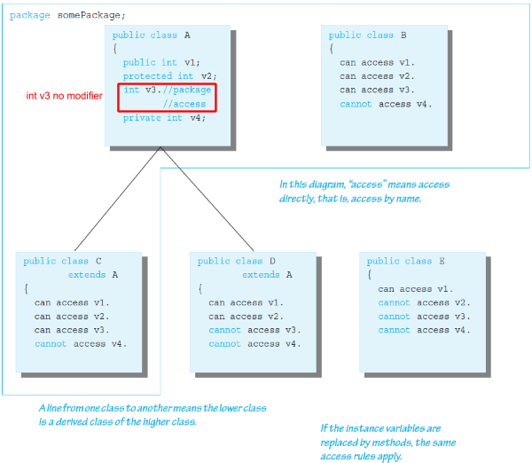
- cannot use multiple supers

- Object class
  - in Java, every class is a descendent of Object
  - if a class not explicitly derived from another class, it is automatically derived from class Object
  - in the java.lang package
  - methods inherited
    - equals, toString, getClass
    - should be overridden, for example:

//must use getClass()!!!! Not instanceof
public boolean equals(Object otherObject){
if(otherObject == null)
return false;
else if(getClass() != otherObject.getClass())
return false;
else{
Employee otherEmployee = (Employee) otherObject;
return (name.equals(otherEmployee.name &&
hireDate.equals(otherEmployee.hireDate));
}
}

- instanceof Operator
  - checks if second argument is the type given，檢查指標變數本身的類型
  - syntax:
Object instanceof ClassName
  - return true, if…
    - Object is of type ClassName
    - Object is a type of any descendent class of ClassName
  - otherwise, return false
- getClass() method
  - every object inherits getClass() from Object，檢查指標變數指到的內容的類型
  - final method (cannot be overridden)
  - returns representation only of the class that was used with new to create the object (to check if exact same class)
  - can compare using == or !=
- Class Class<T>：此種類型，有reflex的功能，可以知道物件內有什麼、物件是什麼
- composition: class contains instance variable of a class type

